NAME:Rishik JK
REG.NO :192511052

CSA1702-ARTIFICIAL INTELLIGENCE
LAB EXPERIMENT

Experiment 10 – A* Algorithm

AIM
To write a Python program to implement the A* Search Algorithm to find the shortest path from a start node to a goal node.

ALGORITHM
- Start the program.
- Create the graph with path costs.
- Assign a heuristic value to each node.
- Start from the initial node.
- Calculate:
f(n) = g(n) + h(n)
- Select the node having the lowest f(n) value.
- Continue until the goal node is reached.
- Display the shortest path and cost.
- Stop the program.

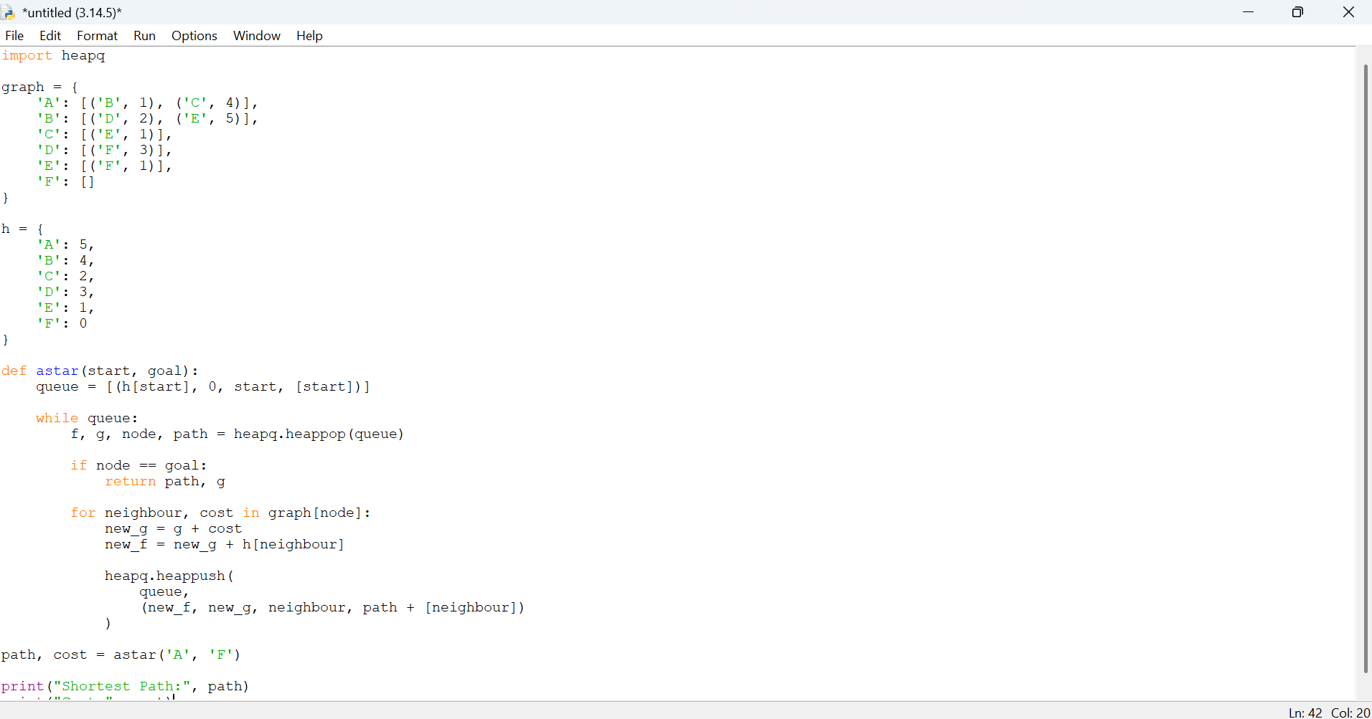

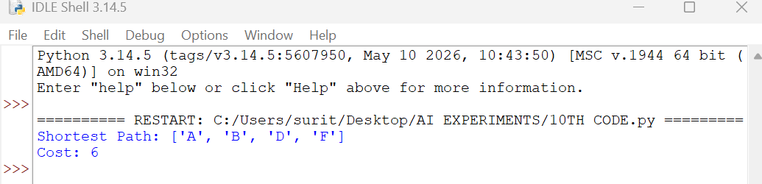

RESULT
Thus, the A* Search Algorithm was implemented successfully using Python and the shortest path from the start node to the goal node was found.

